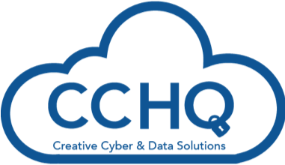

[www.cybercapitalhq.com](http://www.cybercapitalhq.com)

ISO27001 certified

**Cyber Capital HQ Consulting**

**Analysis & Basic risk prevention measures for an Oil and Gas Company**

**Objectives:**

a) Assess and evaluate the robustness of the company’s people, process, and technology framework and corresponding internal controls to manage company’s confidential information and related accessibility.

b) From the above, recommend the most appropriate course of action to strengthen internal processes, controls and related technology to manage critical information, minimize the risk of insider threat and prevent confidential information leakage.

c) Mitigate the legal and financial risk associated with employees’ disgruntlement/dismissals.

**Service Overview**

• As-is analysis: Mapping of controls, processes, and technology to manage company’s information with a particular emphasis on accessibility, users, rights and privileges.

• Classification of information according to levels of confidentiality, criticality, and accessibility.

• To-be analysis: Assessing risk of insider threat and ways to improve controls, processes and implement technology to monitor user activity and logs, minimize the risk of insider threat and information leakage, build evidence around unauthorized user activity and implement an incident response plan. Implement security controls around confidential information.

• Analysis of the company’s HR processes and the legal framework in Africca with a view on minimizing the legal risk and financial impact of employees’ dismissals.

**Deliverables:**

Cyber Capital HQ provided strategic and tactical recommendations to assist the company

• A written report that can be consumed by technical, managerial, and executive personnel

• A debrief presentation, providing anatomy of the findings and recommendations

• A tabletop workshop with involvement from business, professional, and support functions such as HR and legal